Guidance for Completing and Submitting Vegetation/Fuel Management Treatments under the DMAF Program
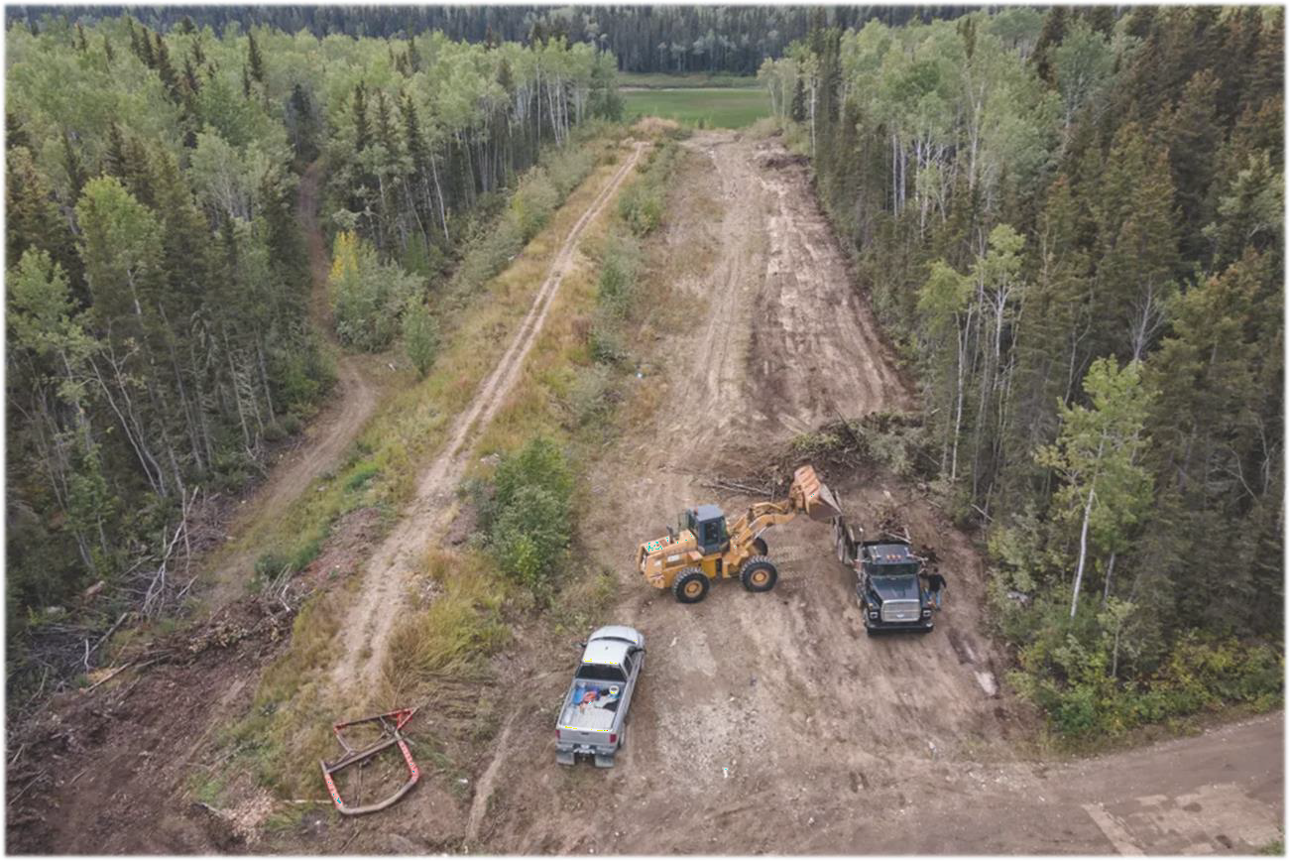
Photo: Cabin Radio

Contents
Introduction 2
Steps for Completing Vegetation/Fuel Management Treatments 2
Details for Filing a Reimbursement Claim 3
Filling out the Claims Spreadsheet 4
Indigenous Consultation Affidavit Form 4
Frequently Asked Questions 5
Eligible Costs Examples 6

Introduction
The Disaster Mitigation and Adaption Fund (DMAF) is a national event intended to support public infrastructure projects designed to mitigate current and future climate-related risks and disasters triggered by climate change, such as floods, wildland fires, droughts and seismic events.
Eligible infrastructure projects under the DMAF include new construction of public infrastructure and/or modification of existing public infrastructure including natural infrastructure that prevent, mitigate or protect against the impacts of climate change, disasters triggered by natural hazards, and extreme weather.
The Government of Canada approved the Northwest Territories Association of Communities (NWTAC) DMAF application for $20M to construct fireguards and fuel breaks around 29 NWT Communities based on recommendations within existing Community Wildfire Protection Plans (CWPP’s). Completion of these vegetation/fuel management treatments will help increase resiliency to wildfire for the identified communities.
This guidance document outlines steps for completing vegetation/fuel management treatments in your community under the DMAF program and the final reporting requirements to receive reimbursement for eligible expenses.

Steps for Completing Vegetation/Fuel Management Treatments:

- Ensure that the area you want to treat has been identified as a proposed vegetation/fuel management area in the most up-to-date Community Wildfire Protection Plan (CWPP) developed for your community by a qualified forest professional. Treatment specifications outlined within the CWPP must be followed.

If you would like to request modifications to the proposed treatment specifications in the CWPP, please contact Sara Brown (CEO, Northwest Territories Association of Communities, sara@nwtac.com) and Forsite Consultants (nwtacfire@forsite.ca).
- Contact and engage with local Indigenous group(s) around your community whose rights and interests may be impacted by the proposed vegetation/fuel management project.

*All communities are responsible for and required to complete First Nations consultation and accommodation to be able to receive reimbursement for eligible project costs.

- Contact your local or regional Environment and Climate Change office to determine if and what type of timber permit may be required for tree removal based on the specifications of your vegetation/fuel management project.
- Contact your regional Land and Water Board to determine if a land use permit is required for your vegetation/fuel management treatment project.
- A burning permit may be required for piling and burning of woody debris from tree/fuel removal. Contact your local or regional Environment and Climate Change office to obtain any necessary burning permits. Please make sure your fire department is aware of any prescribed burns being conducted.

*All communities are responsible for and required to obtain the necessary permits, permissions, licenses, approvals, etc. to be able to receive reimbursement for eligible project costs.
- Put out an Invitation to Tender for the vegetation/fuel management work to be completed. The federal government requires that contracts for the DMAF project work are awarded in a way that is fair, transparent, and competitive. If it is not possible to tender the work, please inform the NWTAC and alternate options can be discussed.
- Complete your vegetation/fuel management project. Upon completion, you can submit claims for reimbursement for eligible costs incurred. Please read the Details for Filing a Reimbursement Claim section below for important information regarding claim requirements.

Details for Filing a Reimbursement Claim
Fiscal filings will need to be filed by April 30 and Sept 30 of each year. Things you will need to submit a claim for reimbursement:
  - A signed Ultimate Recipient Agreement between the community and the NWTAC
  - All invoices and receipts for eligible costs incurred during the planning and implementation of the vegetation/fuel management treatment project. See examples of eligible costs in the Eligible Costs Examples section.
  - All costs have been incurred in accordance with the Ultimate Recipient Agreement.
  - Example photos of the in progress and completed fuel break/fire guard work.
  - The “Community – DMAF Claims spreadsheet” you received from the NWTAC.
  - An Indigenous Consultation Affidavit developed.
  - Date of when contract was signed with supplier.
  - All cost claims have been accounted for in accordance with the Public Sector Accounting Standards in effect in Canada.

  - As a Community Government you stayed in touch with the Indigenous Governments, or you are an Indigenous Government.
  - Land and Water Board permits were acquired if required, an email or letter that confirms this from your water board is required.
  - A timber cutting permit was acquired if required.
  - The number of hectares __________ha completed this claim.

Filling out the Claims Spreadsheet
When filling out the claims spreadsheet, be sure to fill out all columns. Each type of claim should be inserted as a separate line item. The table below provides guidance for each column.

Column Heading | Instruction
Project Cost Category | Refers to the type of cost you are claiming. Examples of eligible costs within each cost category can be found in the Eligible Costs  Examples section of this guide.
Supplier/Contractor Name | The official name of the supplier with whom there is a direct  contract to complete the described work per expenditure.
Date of Signed Contract | The date the contract was signed for each supplier/contractor
Invoice Number(s) | The invoice number for each individual expenditure. If the description of work is the same for multiple invoices for the same supplier, then multiple invoice numbers can be added into one cell  in this section with one description of work. Multiple invoice numbers in a cell should be separated by a comma.
Description of Work | Provide a description of 1-3 sentences for the type of work performed for each invoice/expenditure. Please include the fuel treatment unit the expenditure is applicable to.  If the description of work is the same for the same supplier, these expenses can be bundled by including one description of work in in one cell and including multiple invoice numbers.
Type of Recipient | For NWT communities, this will be either municipal or indigenous.
Total Eligible Cost | The eligible cost claimed under each contract. The amount differs from the invoice amount as it excludes taxes unless the recipient is  not eligible for a tax rebate.
Related Comments | Any pertinent comments related to expenditures (e.g., the expenditure is part of an approved sole source contract or own force  labour).

Indigenous Consultation Affidavit Form
All communities must meaningfully consult with local indigenous communities that may be affected by the project. During indigenous consultation, the community must in an timely, transparent, and responsive manner:
  - inform and explain the objectives and outcomes of the fuel management project,
including Canada’s funding role;
  - Provide Indigenous peoples an opportunity to share their concerns about potential adverse impacts on Aboriginal and/or treaty rights;
  - Determine, where appropriate, how the project can be modified to address concerns, limit or avoid identified adverse impacts; and
  - Ensure identified mitigation and/or accommodation measures are implemented and keep Indigenous peoples informed of developments.

An Indigenous Consultation affidavit form must be completed and submitted to the NWTAC to be eligible for reimbursement of project costs. Costs incurred through the indigenous consultation process may be considered eligible expenditures for reimbursement and should be included in the project cost. The affidavit must include:
- If you are an Indigenous Government;
- A list of indigenous governments contacted;
- A summary of all communications with the indigenous communities;
- A summary of any issues or concerns that the indigenous communities have raised and how they were addressed, and any outstanding concerns.

Frequently Asked Questions

What projects/costs are eligible for funding under the DMAF program?
In July 2022, the DMAF program approved the construction of fuel breaks and fireguards for 29 NWT communities as outlined in the Community Wildfire Protection Plans (CWPP) that were developed by the GNWT. The treatment area must be identified as a proposed vegetation/fuel management area in the most up-to-date CWPP developed for your community. The treatment approach and specifications outlined within the CWPP must be followed. Any fuel management work that has been completed since the time of approval in July 2022 and meets the abovementioned requirements is eligible for reimbursement up to the allocated amount detailed in your community Ultimate Recipient Agreement. This does not include costs associated with FireSmart implementation around homes or work covered by other programs like those in response to the immediate threat of wildfire.
Additionally, there are a variety of other costs associated with the planning and construction of the fuel breaks and fireguards that are eligible for reimbursement under the program. See the Eligible Costs Examples section below for examples.

What if the community wants to make modifications to the proposed treatment specifications in the CWPP?
If you would like to request modifications to the proposed treatment specifications in the CWPP, or add new areas for treatment, please contact Sara Brown (CEO, Northwest Territories Association of Communities, sara@nwtac.com) and Forsite Consultants (nwtacfire@forsite.ca). Your request will be reviewed by the above parties and will be approved provided the outcomes align with overall wildfire risk reduction objectives of the CWPP. An amendment

memorandum and associated maps documenting the requested changes and providing operational direction for proposed treatment activities will be developed and provided.

How long will it take to receive the reimbursement once the claim is submitted?
Time to reimbursement will be variable depending on submission dates of April 30 and September 30. The NWTAC will then do a consolidated submission to the Federal Government.

Eligible Costs Examples
Examples of various eligible costs within each cost category are outlined in the tables below. Remember: The amount of funding available to your community is currently set at the allotted amount outlined in your Ultimate Recipient Agreement. Any costs incurred beyond this amount will not be reimbursable under the DMAF program.

GENERAL COSTS
ELIGIBLE | INELGIBLE
All direct and necessary expenditures incurred by the Ultimate Recipient since July 2022 towards the eligible Project that are associated with acquiring, planning, designing, constructing or rehabilitating a tangible capital asset. For the NWT Wildfire Resilience Project, this pertains to natural infrastructure including fuel breaks and fireguards. | - Public education and training activities  - FireSmart activities around homes  - Non-competitive contracts unless approved as eligible costs by the Minister of Infrastructure and Communities. If your community cannot put out a competitive tender process for the completion of the work due to lack of local contractors, you must inform Sara Brown (sara@nwtac.com) to obtain approval from the Federal Government.  - Any project costs incurred prior to the date of approval letter (July 2022).  - Legal fees  - Any overhead expenditures, including: salaries of any employees; direct or indirect operating or administrative costs; and any other activities normally carried out by the Ultimate Recipient, with the following exceptions:  - the overhead costs for the purpose of Indigenous consultation/engagement  activities; and

DESIGN/ENGINEERING
ELIGIBLE | INELIGIBLE
All planning costs and evaluation, such as environmental planning, surveying, engineering, supervision costs, and costs related to management consulting services. | - Feasibility studies

- Example: project management costs for implementation of the proposed fuel treatments
- Costs for environmental assessments

INDIGENOUS CONSULTATION
ELIGIBLE | INELIGIBLE
Overhead costs and other costs for the purpose of meaningful indigenous engagement and consultation activities, including but not limited to:  - Professional fees/consultation fees;  - Travel expenses;  - Hospitality expenses;  - Honoraria for Elders and Chiefs to attend meetings;  - Ceremonial offerings related to environmental assessments and Indigenous consultation;  - Other expenses related to local collection/distribution of information;  - Rental of office space/meeting rooms;  - General media advertising/promotion;  - Purchase of information material;  - Other relevant consultation capacity building. | - Legal fees  - Alcohol

ENVIRONMENTAL ASSESSMENT
ELIGIBLE | INELIGIBLE
Potential environmental assessment costs could include:  - Qualified Environmental Professional services e.g. Breeding bird surveys  - Environmental reviews  - Remedial activities  - Mitigation measures | - Legal fees

COMMUNICATION ACTIVITIES
ELIGIBLE | INELIGIBLE
Costs of joint communications activities set out in the Communications Protocol that accompanies the Ultimate Recipient Agreement. These communications products are only eligible if they are incurred as part of a federal or federally- partnered joint communication.  Examples include:  - Tender ads  - Photography | - All non-joint communication activities related to the project  - Salaries related to communications activities  - Event planners  - Communication plans  - Media consultant  - Promotional items or ads

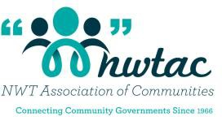

- Printed materials regarding the project
- Project signage
- Translation

CONSTRUCTION WORK
ELIGIBLE | INELIGIBLE
Contractor labour costs for completing the fuel
management work
License and permit fees associated with land use and construction of the fuel management features
Project management costs
First Aid attendant on site | - Ambulance for workplace accidents  - First Aid courses
Equipment necessary for project construction (machinery, chain saws, pruners, etc.) | - Tools (e.g. Shovel, measuring tape, PPE and clothing, hoses, garbage cans, etc.)
Towing heavy equipment to and from the site
Safety equipment to be kept at the project site (first aid kit, safety goggles, etc.)

